Assignment 1 18 April 2020

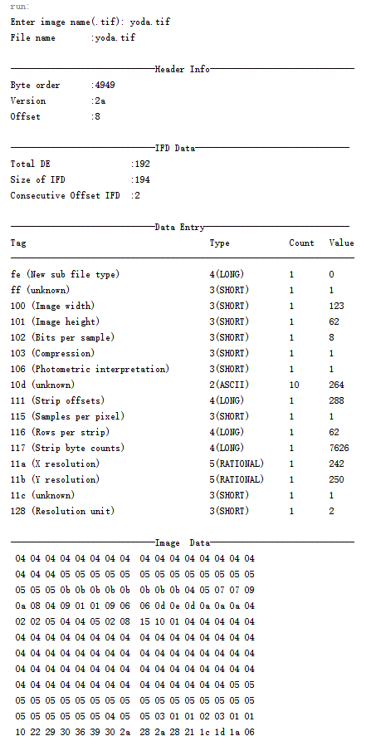

Assignment 2 Q1

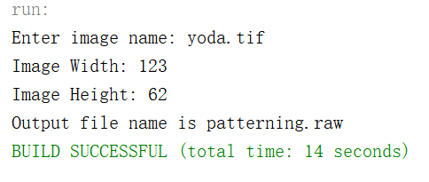

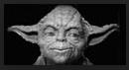 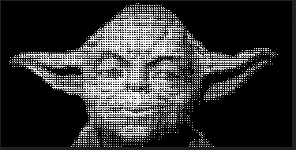

yoda.raw (original image) patterning.raw

Assignment 2 Q2

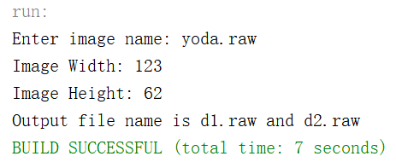

 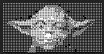 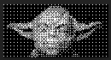

yoda.raw (original image) d1.raw d2.raw

Assignment 3

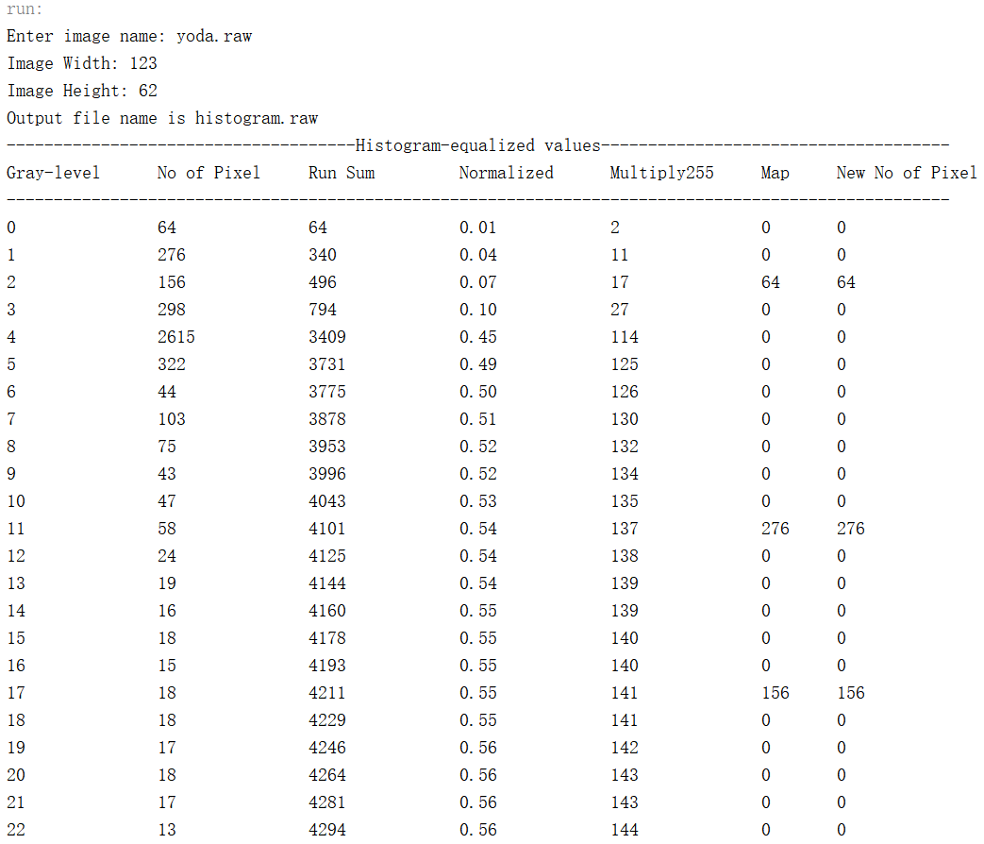

 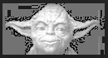

yoda.raw (original image) histogram.raw

Assignment 4

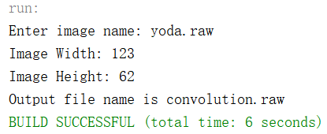

 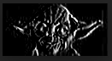

yoda.raw (original image) convolution.raw

Assignment 5

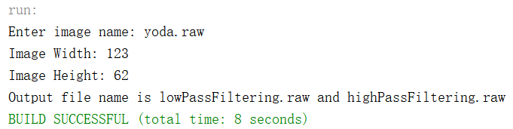

 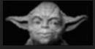 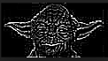

yoda.raw (original image) lowPassFiltering.raw highPassFiltering.raw